**Chapter 1: Introduction**

This chapter lays the groundwork for the project by establishing a broad context, detailing historical evolutions, and illuminating both theoretical and practical aspects of microprocessors and multiplexers. Through an enriched discussion, we will reveal the significance of these components in modern computing and explain how their interplay forms the basis of the project.

**1.1 Background of Microprocessors**

**Definition and History**

* A close-up of a chip

  AI-generated content may be incorrect.**Definition:** A microprocessor is an integrated circuit that holds the central processing unit (CPU) functionality within a single chip. It interprets and executes digital instructions.

Figure :Intel 4004

* **Historical Milestones:**
  + 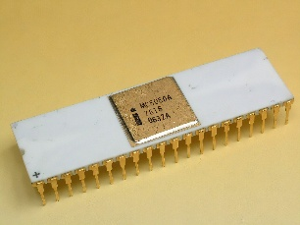The introduction of the Intel 4004 laid the foundation for modern microprocessors.

Figure :Intel 8080

* + Subsequent developments, like the Intel 8080 and Motorola 6800, accelerated the evolution from mainframe computers to personal computing.

Figure :Motorola 6800

* + 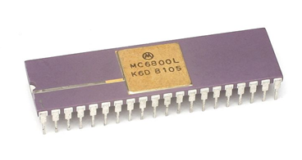Advancements in miniaturization and fabrication technologies (e.g., CMOS) have allowed for billions of transistors on a single chip.
* **Evolution in Design:**
  + The shift from simple, single-core processors to complex multi-core architectures highlights the dramatic improvements in performance and energy efficiency.
  + Exploration of microcontrollers alongside microprocessors shows how integration of peripheral functions evolved digital device design.

**Importance in Modern Computing**

* **Core Role in Devices:**
  + Microprocessors are the heart of modern computing devices, enabling operations within smartphones, laptops, embedded systems, and servers.
* **Impact on Technology and Innovation:**
  + The scaling of microprocessor technology is directly linked to advancements in artificial intelligence, IoT devices, and real-time processing systems.
* **Catalyst for Digital Transformation:**
  + Their evolution has been crucial for the miniaturization of electronic devices and has spurred innovations in computer architecture and software paradigms.
* **Interdisciplinary Influence:**
  + The technology behind microprocessors influences areas ranging from consumer electronics to aerospace, demonstrating its ubiquitous impact throughout society.

**1.2 Overview of Multiplexers**

**Definition and Function**

* **Basic Concept:**
  + A multiplexer acts as a digital switch that channels multiple input signals into a single output line, based on control (select) signals.
* **Core Functionality:**
  + It enables efficient data routing, reduces the number of pathways required, and simplifies hardware wiring in complex systems.
* **Advanced Routing:**
  + Multiplexers can dynamically select inputs based on timing or priority, which is essential for high-speed data communication and processing.

**Types of Multiplexers**

* **Categorization by Input Ratio:**
  + **2:1 Multiplexer:** Two inputs controlled by a single selection line. A diagram of a circuit

    AI-generated content may be incorrect.

Figure :2x1 Multiplexer

* + **4:1 Multiplexer:** Four inputs managed with two control lines. 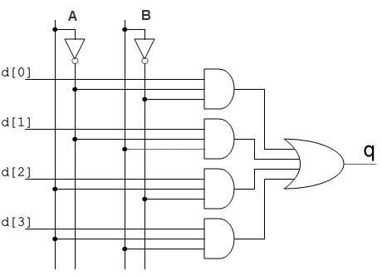

Figure :4x1 Multiplexer

* + **8:1 Multiplexer:** Eight inputs requiring three control lines. A diagram of a rocket

    AI-generated content may be incorrect.

Figure :8x1 Multiplexer

* **Comparison with Demultiplexers:**
  + Unlike multiplexers that consolidate data channels, demultiplexers expand a single input into multiple outputs, often complementing multiplexer functions in circuit designs.
* **Specialized Multiplexer Designs:**
  + Time-division multiplexing (TDM) and frequency-division multiplexing (FDM) serve distinct roles in communication systems, with digital multiplexers adapting similar principles for data routing.

**Applications in Digital Circuits**

* **Data Routing:**
  + They are employed to manage data flow within CPUs, directing signals between registers, arithmetic logic units (ALUs), and memory units.
* **Circuit Simplification:**
  + Multiplexers reduce circuit complexity by consolidating multiple signal pathways into a single route, which simplifies PCB layouts.
* **Real-World Implementations:**
  + Used in bus systems and network-on-chip designs, they ensure efficient communication across various circuit components.
* **Integration in Signal Processing:**
  + Their use in analog-to-digital converter chains and control logics illustrates a bridge between analog systems and digital processing.

**1.3 Objectives of the Project**

In adding further depth, the project has several interrelated objectives:

* **Design Implementation:**
  + Architect a basic microprocessor that utilizes multiplexers as the primary means for data routing.
  + Implement fundamental processing operations (e.g., data fetching, execution, and result storage) using multiplexing circuits.
* **Performance Analysis:**
  + Evaluate the performance implications of using multiplexers in key functions, including latency, throughput, and signal integrity.
* **Educational Insight:**
  + Use the project as a teaching tool to illustrate how simple digital components can come together to emulate complex computing logic.
* **Simulation and Validation:**
  + Employ simulation environments (such as Verilog or VHDL) to model and test the designed circuits, ensuring functionality and exploring design trade-offs.
* **Scalability Study:**
  + Investigate how the basic design can be expanded or refined for more complex, real-world applications, thus balancing simplicity with potential future enhancements.
* **Resource Efficiency:**
  + Analyze the trade-offs between hardware resource usage and performance, offering insights into optimal multiplexer configurations for various digital systems.

**1.4 Scope of the Project**

**Limitations and Assumptions**

* **Simplified Architecture:**
  + The design intentionally minimizes complexities such as error correction, advanced clock management, and power optimization to maintain focus on core functions.
* **Ideal Conditions:**
  + The project assumes idealized circuit conditions, such as perfect signal integrity and negligible environmental interference, to isolate the principles of multiplexer-based routing.
* **Model Constraints:**
  + Focus is placed on static signal routing without delving deeply into dynamic power management or real-time operational challenges.
* **Educational Focus:**
  + Designed primarily as an educational prototype, the microprocessor serves as a practical demonstration rather than a market-ready product.

**Potential Applications of the Designed Microprocessor**

* **Educational Use:**
  + Provides a hands-on learning tool for undergraduate and graduate-level courses in digital electronics and computer architecture.
* **Prototype for Research:**
  + A baseline model for exploring improvements in microprocessor design, allowing further research into more sophisticated applications.
* **Experimental Platform:**
  + Can be used to test integration with other digital components (e.g., decoders, encoders) and to simulate more complex processing architectures.
* **Embedded System Applications:**
  + While simplified, the design offers a pathway to developing low-power, cost-effective embedded systems for niche applications.
* **Scalability and Adaptability:**
  + The modular design lays the groundwork for future scalability studies in enhancing processing speed, integrating memory modules, and developing error-detection mechanisms.

**Additional Points for Consideration**

* **Historical Context and Future Trends:**
  + Explore the evolution from early transistor-based designs to modern multi-core systems.
  + Discuss future trends in microprocessor technology such as neuromorphic computing and quantum processors, and contrast these with the established methodologies.
* **Interdisciplinary Relevance:**
  + Highlight the cross-disciplinary relevance of multiplexers—from telecommunications to robotics—demonstrating how basic digital routing underpins advancements in various fields.
* **Comparative Analysis:**
  + Consider comparisons of different multiplexer configurations, weighing the pros and cons of 2:1 versus 8:1 designs in terms of physical layout, speed, and complexity.
* **Design Trade-offs:**
  + Analyze the balance between cost, complexity, and performance in digital design. Provide insights into how engineers must align component choices with practical constraints.
* **Real-World Implementation Challenges:**
  + Detail anticipated challenges such as signal interference, thermal fluctuations, and component variability, even if the project abstracts these complexities.
* **Future Extensions:**
  + Suggest pathways for extending this research, such as integration with programmable logic devices (FPGAs) or the incorporation of error detection and correction techniques.
* **Interplay with Other Components:**
  + Emphasize how the multiplexer-based design can be paired with other digital components like decoders, encoders, and even simple arithmetic units to form a more comprehensive processor model.

**What’s Next?**

This detailed and enriched introduction not only sets the technical stage but also widens the intellectual horizon for the project. The forthcoming chapters will delve into design methodologies, experimental results, and a comparative study of alternative approaches, further exploring concepts such as clock distribution, pipelining challenges, and real-time data processing enhancements. This multi-faceted approach is meant to encourage further inquiry and innovation in the field of digital electronics and microprocessor design.

**Table of Figures:**

Figure 1:Intel 4004 1

Figure 2:Intel 8080 1

Figure 3:Motorola 6800 1

Figure 4:2x1 Multiplexer 2

Figure 5:4x1 Multiplexer 3

Figure 6:8x1 Multiplexer 3